Generating Data
Table 1-1
1 | 2 | 3 | 4 | 5 | 6
Person | True Score (T) | Pretest Error  (e_{X}) | Posttest Error  (e_{Y}) | Pretest X | Posttest Y
1
2
3
4
5
6
7
8
9
10
11
12
13
14
15
16
17
18
19
20
21
22
23
24
25

Generating Data
Table 1-1 (cont.)

1 | 2 | 3 | 4 | 5 | 6
Person | True Score (T) | Pretest Error  (e_{X}) | Posttest Error  (e_{Y}) | Pretest X | Posttest Y
26
27
28
29
30
31
32
33
34
35
36
37
38
39
40
41
42
43
44
45
46
47
48
49
50
Generating Data
Figure 1-1
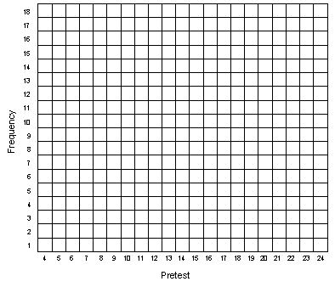
Generating Data
Figure 1-2
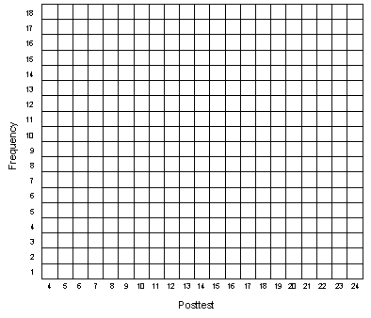

Generating Data
Figure 1-3
